IB Art History IA
Comparative Investigation
Research and Sources

Table of Contents
- Types of Sources
- Preliminary Research Question
- Citing Images of Artworks
- Organizing Your Research with Tables
- Jumpstart Your Research
- Citing Images of Artworks
- Researching with Academic Databases
- University Guides to Writing in Art History and Analyzing Art

Types of Sources
Minimum 5 sources – 3 on primary work; 2 on secondary
- Exhibition catalogs
For example: Wendy Red Star: A Scratch on the Earth
Search The Met’s collection of digitized Exhibition Catalogs

- Monographs (books)
For example: https://read.dukeupress.edu/books/book/3172/Dissident-PracticesBrazilian-Women-Artists-1960s
Calirman, Claudia. Dissident Practices: Brazilian Women Artists, 1960s–2020s. Duke UP, 2023.

- Textbooks
For example: IB Visual Arts Online Course Book: Oxford IB Diploma Programme

- Scholarly essays
For example: https://www.e-flux.com/journal/49/59999/world-history-and-earth-art/

- Articles
For example: https://www.artforum.com/features/murtaza-vali-on-the-art-of-pacita-abad-252743/

- Museum websites
For example: https://www.menil.org/exhibitions/261-works-by-cy-twombly

Getty Research Portal - Getty Research Institute's collection of digitized art history texts.

Preliminary Research Question
Preliminary Research Question
- Revisit where topic comes up in course content
- Use reference sources (also called tertiary sources)
  - “Art History for Dummies Cheat Sheet” - Scroll through a table of major art historical movements and representative features
  - The Art Story.org - Artist, Movements, Ideas and Concepts
  - Tate’s Art Terms
  - Textbooks and reference databases
  - Museum websites
  - even Wikipedia, as a starting point
→ Use reference sources to gather the key words for your research.

Identify topics for your comparative investigation research question
Practice drafting and refining potential topics for your comparative investigation to develop into a research question:

Step 1 - TOPIC: Name an (primary) artwork, artist, or art movement and identify
I am studying/looking into _______
Step 2 - QUESTION [Q1]: Add an Indirect Question that indicates the formal feature, subject matter, technique, process, context, reception, or interdisciplinary connection of the art that you want to investigate (and then compare to other artwork):
Because I want to investigate and analyze ______,
or
Because I want to find out who/what/when/where/whether/why/how ____,
When you add that because I want to find out how/why/whether clause, you state why you are pursuing your topic: to answer a question important to you.
Step 3 - SIGNIFICANCE [Q2]: Answer So What? by Motivating Your Question
In order to interpret how, why, or whether ____, in comparison with ____ [secondary artwork or artist].
This question asks you to identify how the topic you’re interested in touches on issues important to the study of art history and comparative interpretations of artworks.

Citing Images of Artworks
Find images of both your primary and secondary artworks. Embed and cite them in your essay.

Reference and Image Resources

The Met's Heilbrunn Timeline of Art History - reference for art historical context
“The Timeline of Art History presents the Met’s collection via a chronological, geographical, and thematic exploration of global art history. Targeted at students and scholars of art history, it is an invaluable reference, research, and teaching tool. Authored by the Met’s experts—predominantly made up of curators but also of conservators, scientists, and educators—the Timeline comprises 300 timelines, 930 essays, close to 7,000 objects, and a robust index, and is regularly updated and enriched to provide new scholarship and insights on the collection.”
Britannica Online Library Edition - reference for art historical context

Visit this Purdue OWL web page and scroll down to the "Painting, Sculpture, or Photograph" section for guidance on citing the high-quality images you use in your paper.

Recommended websites for finding high-quality images of artworks:
- National Gallery of Art, open access images
- Google Arts and Culture
- The Metropolitan Museum of Art
- Digital Public Library of America
- Europeana
Rice University Library Guide to Art History, selected Library & Museum Websites
Wake Forest Library guide for Art HistoryResearch Resources: Finding Images and Websites
Medium | Reference and citation
Painting | Embed image in text:  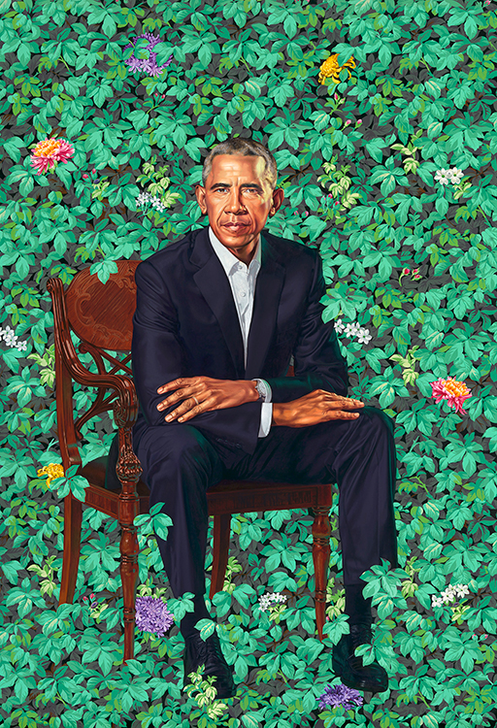  (Wiley, “President Barack Obama”)  Wiley, Kehinde. “President Barack Obama.” 2018, National Portrait Gallery, Washington, D.C., npg.si.edu/Barack_Obama. Accessed 18 Oct 2023.  Artist's Last Name, First Name. Title of Artwork. Date Artwork Created, Name of Institution or Private Collection Housing Artwork, City Where it is Housed.
Photograph | Embed image in text:    (Hussey, “The Soldier”)  Works Cited:  Hussey, Tom. “The Soldier.” Reflections, Hussey Photography, 2013, www.tomhussey.com/STORIES/REFLECTIONS/2. Accessed 18 Oct 2023.  Last-name, First-name. “Title of the Picture.” Story, Title of the Site, Date, URL. Accessed Date.
Image or illustration in print | Embed image in text:  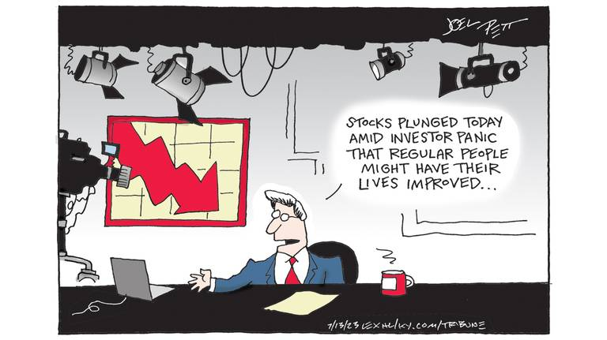  (Pett, “Wall Street v. Main Street”)  Works Cited:  Pett, Joel. “Wall Street v. Main Street.” Lexington Herald-Leader, 12 Jul 2023, www.kentucky.com/opinion/editorial-cartoons/joel-pett/. Accessed 18 Oct 2023.  First-name, Last-name. "Title if Any." Publication Name, date of publication, page number or URL if online.Accessed date.

Organizing Your Research with Tables

(CONTEXTUAL RESEARCH) Using McFee’s (1978) Conceptual Framework
Click here to save a copy of this table in your own Google Drive
(From collection of IBVA visual organizers in this PDF.)

[paste image of artwork and full citation here]
Artist's Last Name, First Name. Title of Artwork. Date Artwork Created, Name of Institution or Private Collection Housing Artwork, City Where it is Housed. URL. Accessed date.

Audience’s World → | Audience → | ARTWORK | ← Artist | ← Artist's World
The audience’s world is a context in which events of significance occur. Events of significance need to be researched as they impact the way artworks are valued and understood. The collective experience of a particular age or place can also be described as the audience’s world as well as a place for the existence of cultural beliefs, values, religions, rituals, ideas and concepts that also impact the way artworks are understood. | The audience can comprise discreet individuals and collectives who bring different experiences of the world to their understanding of an artwork.  An audience can be contemporary to the time and place the work was created in, or from outside the same time and place.  An audience can be informed or uninformed. | The artwork is considered as a sole entity. It is identified by its creator’s name, title, medium and size. The formal qualities, mood, any signs and symbols used to convey meaning are considered. | The artist is the author of the work. The artist’s practice can be informed by any association with styles, schools or movements.  The technical processes and intent of the artist are considered. | The artist’s world is a context in which events of significance occur.  Events of significance for the artist can be the collective experience of a particular age or place but may also be deeply personal experiences.  Events of significance need to be researched as they impact the way artworks are created. The cultural beliefs, values, religions, rituals, ideas and concepts also impact the way an artist creates.
Paste full references for all sources included in the table here. Use parenthetical citations throughout the table, with the author’s last name and page number if applicable (Lastname #). Purdue OWL here

(FORMAL ANALYSIS) Research notes using Feldman’s art criticism model
Click here to save a copy of this table in your own Google Drive

[paste image of artwork and full citation here]
Artist's Last Name, First Name. Title of Artwork. Date Artwork Created, Name of Institution or Private Collection Housing Artwork, City Where it is Housed. URL. Accessed date.
Description
Analysis
Interpretation
Judgment
Paste full references for all sources included in the table here. Use parenthetical citations throughout the table, with the author’s last name and page number if applicable (Lastname #). Purdue OWL here

Jumpstart Your Research

The Art Story.org - Artist, Movements, Ideas and Concepts (Western Art)
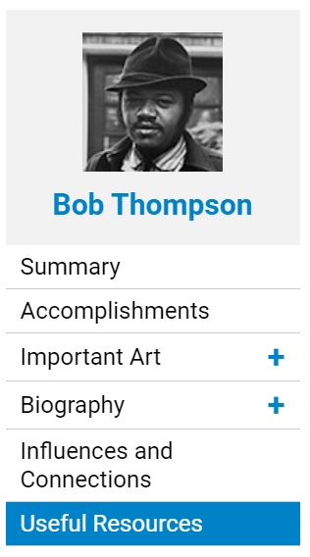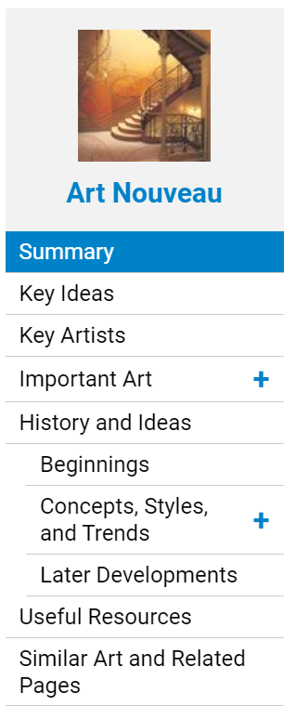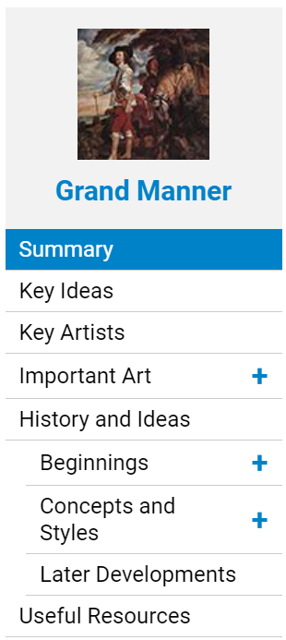
- Browse and/or search relevant Artist, Movement, and “Ideas” pages to identify key terms/categories as well as in-depth timelines of important artworks and their cultural and art-historical contexts with reference to a variety of relevant sources.
- The Useful Resources sections have an “Articles” tab that can point you to great sources for cultural and critical context and responses
- Take notes on subject-specific language used in connection with your selected artists, works, and connecting theme, idea, subject, or style
CITE
Scroll to the “Do more” section at the bottom of article page and click “Cite article”

Copy the comprehensive citation information in the “Cite this Page” pop-up:
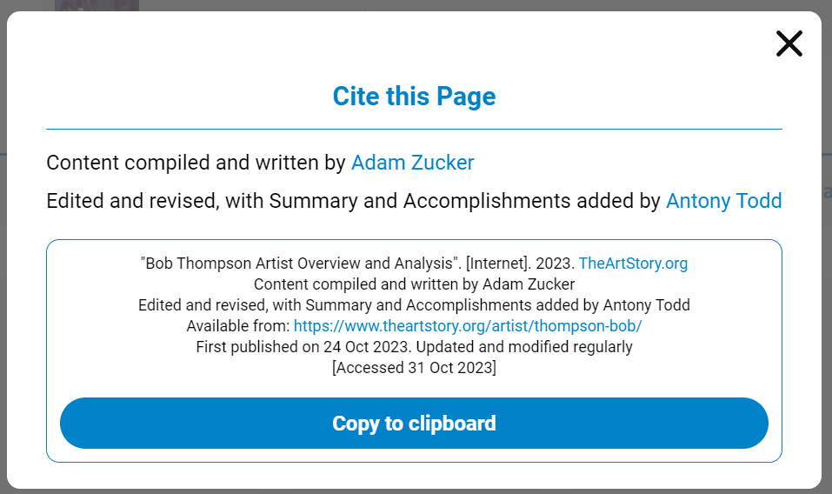
Paste the citation into your notes and/or “References” doc:
"Bob Thompson Artist Overview and Analysis". [Internet]. 2023. TheArtStory.org
Content compiled and written by Adam Zucker
Edited and revised, with Summary and Accomplishments added by Antony Todd
Available from: https://www.theartstory.org/artist/thompson-bob/
First published on 24 Oct 2023. Updated and modified regularly
[Accessed 31 Oct 2023]

Now modify the citation to fit MLA citation style:
Zucker, Adam, with Anthony Todd. “Bob Thompson Artist Overview and Analysis.” TheArtStory.org, 24 Oct 2023. www.theartstory.org/artist/thompson-bob/. Accessed 31 Oct 2023.
Last name, First name. “Title of Page.” Website, Date published. URL. Accessed date.


Scholar.Google.com
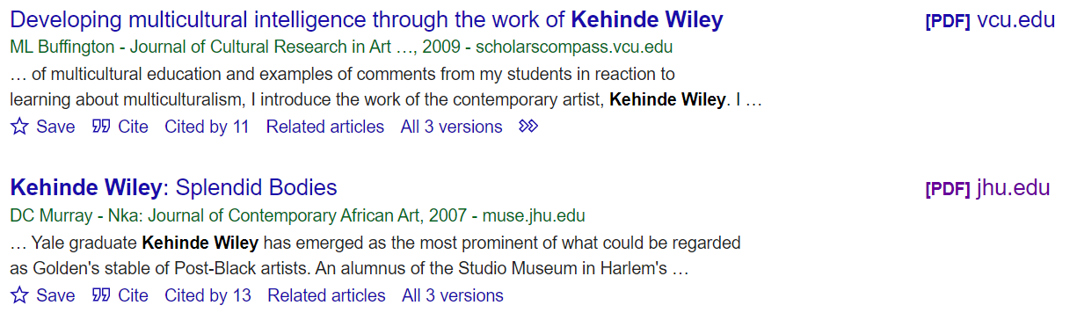
Look for the [PDF] links in the right column by your search results.
Click the link to view and download the PDF of the article.
Start by searching just the artist and/or artwork. What patterns do you notice in the results? Are there specific aspects of the artist’s process, style, tradition, or message that spark your interest for further research?
Look up unfamiliar and subject-specific terms in the Tate’s Art Terms list.

Jstor.org
Click the “Log in” button and then Select “Find my institution”
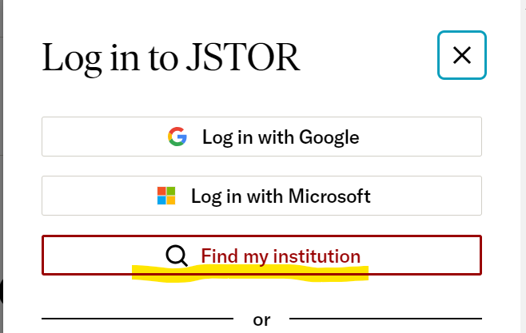
Start typing “Houston Public Library” and select “Houston Public Library (remote access)”
from the dropdown menu:
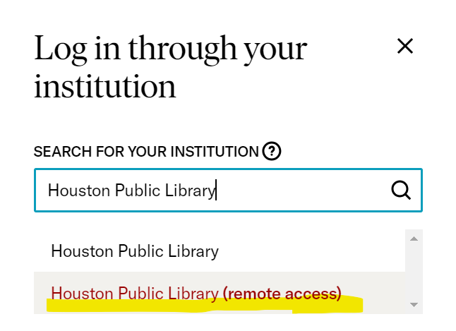
Then enter your “Library Card Number” and “PIN” as described in the image below:
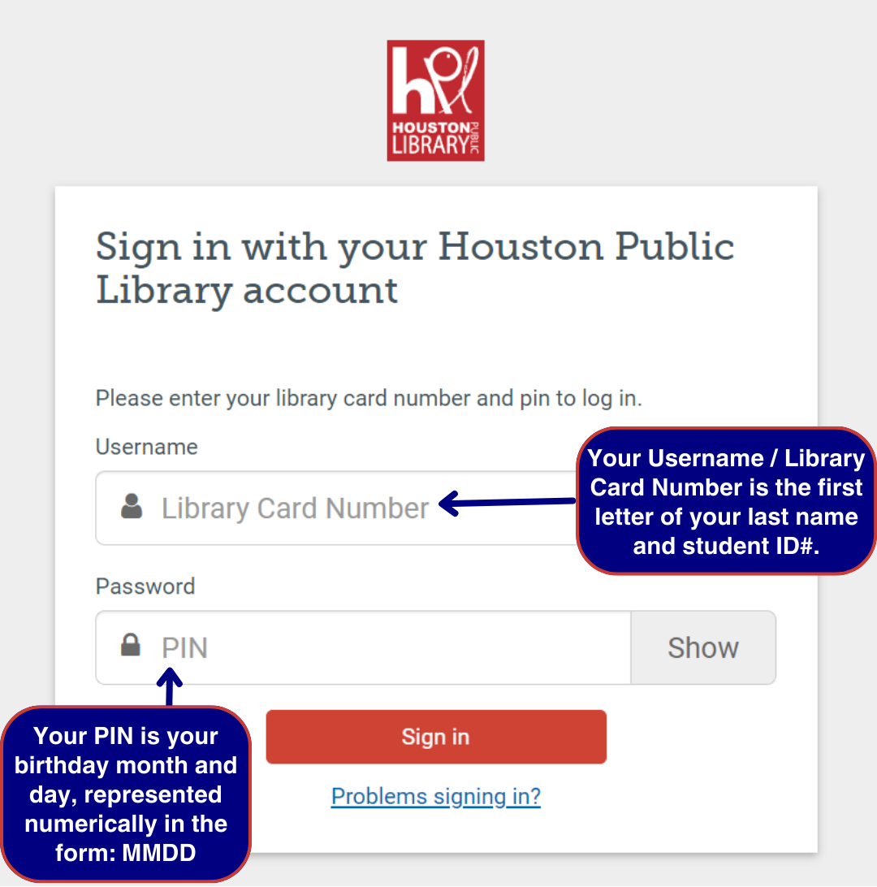

Researching with Academic Databases

Researching with Academic Databases
*Every time you find an academic article you might use, DOWNLOAD AND SAVE IT IN A GOOGLE DRIVE FOLDER TITLED
“IB Art History IA” or “IB Art History Comparative Investigation”
🏪Access Academic Databases and Ebooks through
the Houston Public Library Website

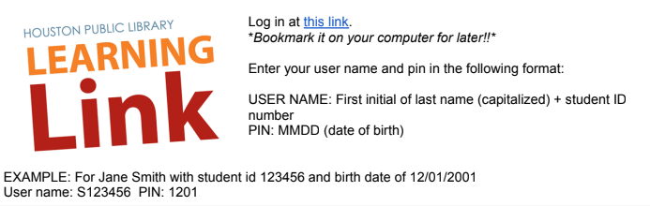

Access academic databases through Houston Public Library using the login instructions above.

Access databases HPL subscribes to and search for sources at houstonlibrary.org/az.php.


Once you’re logged into your library account, select A-Z Databases from the Research drop-down menu.

Under G you’ll find Gale Academic OneFile:




Access ProQuest directly at ProQuest.com. Click Log in through your library:

Choose Open Athens:


Search “Houston Public Library” and choose it from the drop-down menu:
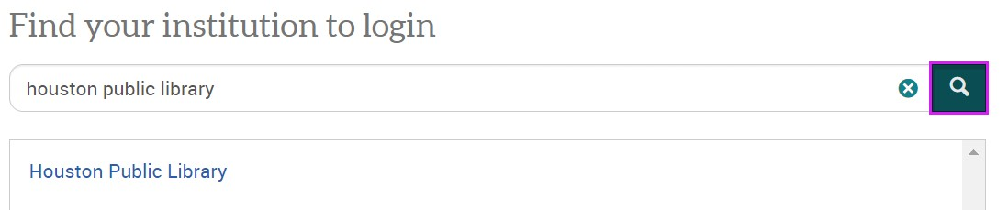

Use your same login to sign in with your Houston Public Library account:

When you’re signed in, you’ll see Access provided by Houston Public Library at the top of the webpage:


University Guides to Writing in Art History and Analyzing Art
Use the guides in the tables below for ideas of Art Historical questions and features to consider in your comparative investigation of artworks.
You can also use these guides to identify search terms for finding sources.

Writing in Art History: Comparison Essays
UNC Writing Center

Pre-writing: observations and note-taking
You can begin this kind of essay with the same process of observations and note-taking outlined above for formal analysis essays. Consider using the same questions and categories to get yourself started.
Here are some questions you might ask:
- What techniques were used to create these objects?
- How does the use of color in these two works compare? Is it similar or different?
- What can you say about the composition of the sculpture? How does the artist treat certain formal elements, for example geometry? How do these elements compare to and contrast with those found in the painting?
- How do these works represent their subjects? Are they naturalistic or abstract? How do these artists create these effects?
Why do these similarities and differences matter?

Comparing and Contrasting from UNC Writing Center

Here are some general questions about different types of things you might have to compare. These are by no means complete or definitive lists; they’re just here to give you some ideas—you can generate your own questions for these and other types of comparison. You may want to begin by using the questions reporters traditionally ask: Who? What? Where? When? Why? How? If you’re talking about objects, you might also consider general properties like size, shape, color, sound, weight, taste, texture, smell, number, duration, and location.

Two historical periods or events

When did they occur—do you know the date(s) and duration? What happened or changed during each? Why are they significant?

What kinds of work did people do? What kinds of relationships did they have? What did they value?

What kinds of governments were there? Who were important people involved?

What caused events in these periods, and what consequences did they have later on?

Two ideas or theories

What are they about?

Did they originate at some particular time?

Who created them? Who uses or defends them?

What is the central focus, claim, or goal of each? What conclusions do they offer?

How are they applied to situations/people/things/etc.?

Which seems more plausible to you, and why? How broad is their scope?

What kind of evidence is usually offered for them?

Two pieces of writing or art

What are their titles? What do they describe or depict?

What is their tone or mood? What is their form?

Who created them? When were they created? Why do you think they were created as they were? What themes do they address?

Do you think one is of higher quality or greater merit than the other(s)—and if so, why?

For writing: what plot, characterization, setting, theme, tone, and type of narration are used?

Two people

Where are they from? How old are they? What is the gender, race, class, etc. of each?

What, if anything, are they known for? Do they have any relationship to each other?

What are they like? What did/do they do? What do they believe? Why are they interesting?

What stands out most about each of them?

Deciding what to focus on

By now you have probably generated a huge list of similarities and differences—congratulations! Next you must decide which of them are interesting, important, and relevant enough to be included in your paper. Ask yourself these questions:

What’s relevant to the assignment?

What’s relevant to the course?

What’s interesting and informative?

What matters to the argument you are going to make?

What’s basic or central (and needs to be mentioned even if obvious)?

Overall, what’s more important—the similarities or the differences?

Writing in Art History: Visual Analysis
UNC Writing Center
Composition
- How are all the different components of the object or image arranged?
- What do you notice first, and why?
- How does the work lead you through the composition?
- Is the composition symmetrical or asymmetrical? If asymmetrical, is the composition balanced in some way?
Technique
- Was the object or image built up by adding material, or was it created by carving away material?
- What kind of paint or finish was added to the material?
- Does the technique seem methodical or spontaneous? How so?
Color
- What colors are present? How are the colors arranged?
- Do the colors appear saturated or muted?
- Are the colors warm or cool?
- Do the colors complement one another or does one clash with the others?
Texture
- Does the material have a physical texture? How would you describe it? What creates the texture?
- Does the material simulate or imply texture in some way, even if on a flat surface? How so?
Line
- Are contour lines present?
- How would you describe the quality and direction of the lines (for example, heavy or thin, rough or smooth, short or long, horizontal, vertical, or diagonal)?
- How do lines create movement or a sense of direction?
- What are any figures depicted looking at or gesturing towards?
Scale
- How large is the object overall? Is the size typical for this kind of object or for this kind of subject?
- Are some components of the object larger than others?
- For two-dimensional materials, how does scale affect the relationship between the objects represented? Are some objects smaller or larger than you might expect?
- For two-dimensional materials, how is space suggested? Do forms overlap, or do they seem to stack on top of each other?
Material
- What materials is the object or image made of?
- How are those materials distributed (if there’s more than one)?
- What effects do the juxtaposition of materials create?
Shape
- Are the figures naturalistic or abstract?
- Are the forms geometric or organic?
- How do shapes repeat throughout the composition?
- For figures, are the proportions distorted, elongated, or idealized?
- What kinds of shapes are formed from the negative space?

Guidelines for the Analysis of Art
From UALR School of Art and Design
In any analysis, keep in mind: HOW and WHY is this a significant work of art?

Part I – General Information
- In many cases, this information can be found on a label or in a gallery guidebook. An artist’s statement may be available in the gallery. If so, indicate in your text or by a footnote or endnote to your paper where you got the information.
- Subject Matter (Who or What is Represented?)
- Artist or Architect (What person or group made it? Often this is not known. If there is a name, refer to this person as the artist or architect, not “author.” Refer to this person by their last name, not familiarly by their first name.)
- Date (When was it made? Is it a copy of something older? Was it made before or after other similar works?)
- Provenance (Where was it made? For whom? Is it typical of the art of a geographical area?)
- Location (Where is the work of art now? Where was it originally located? Does the viewer look up at it, or down at it? If it is not in its original location, does the viewer see it as the artist intended? Can it be seen on all sides, or just on one?)
- Technique and Medium (What materials is it made of? How was it executed? How big or small is it?)

Part II – Brief Description
In a few sentences describe the work. What does it look like? Is it a representation of something? Tell what is shown. Is it an abstraction of something? Tell what the subject is and what aspects are emphasized. Is it a non-objective work? Tell what elements are dominant. This section is not an analysis of the work yet, though some terms used in Part III might be used here. This section is primarily a few sentences to give the reader a sense of what the work looks like.

Part III – Form
This is the key part of your paper. It should be the longest section of the paper. Be sure and think about whether the work of art selected is a two-dimensional or three-dimensional work.

Art Elements
- Line (straight, curved, angular, flowing, horizontal, vertical, diagonal, contour, thick, thin, implied etc.)
- Shape (what shapes are created and how)
- Light and Value (source, flat, strong, contrasting, even, values, emphasis, shadows)
- Color (primary, secondary, mixed, complimentary, warm, cool, decorative, values)
- Texture and Pattern (real, implied, repeating)
- Space (depth, overlapping, kinds of perspective)
- Time and Motion

Principles of Design
- Unity and Variety
- Balance (symmetry, asymmetry)
- Emphasis and Subordination
- Scale and Proportion (weight, how objects or figures relate to each other and the setting)
- Mass/Volume (three-dimensional art)
- Rhythm
- Function/Setting (architecture)
- Interior/Exterior Relationship (architecture)

